8-Puzzle Problem

AIM:
To write a Python program to solve the 8-Puzzle Problem using a search algorithm.

ALGORITHMS:
1.Start.
2.Initialize the initial state and goal state.
3.Generate possible moves of the blank tile.
4.Check each new state.
5.Repeat until the goal state is reached.
6.Display the solution path.
7.Stop.

CODE:
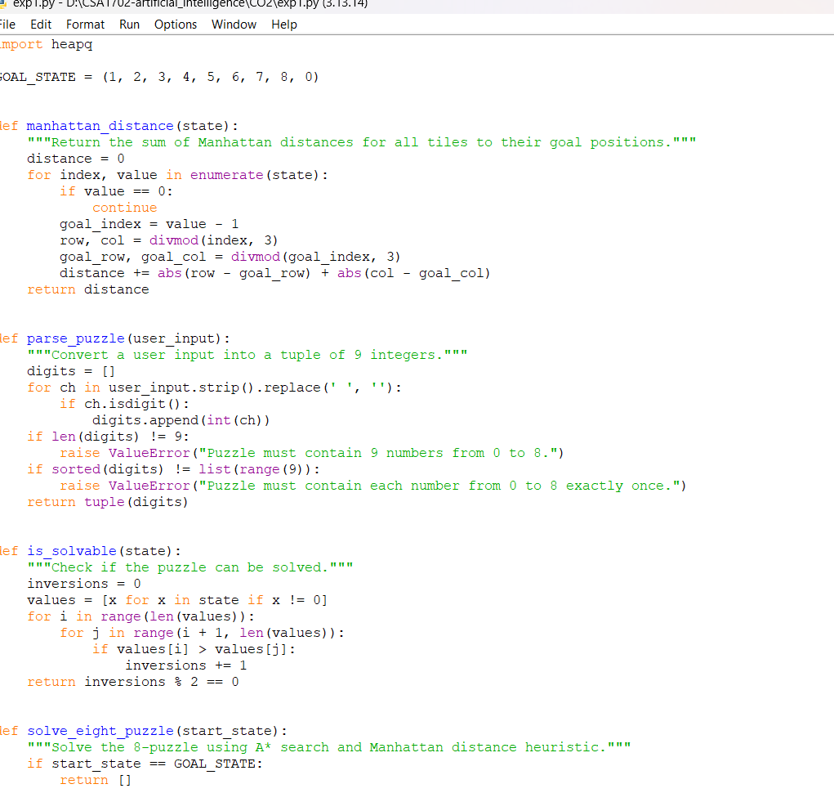

OUTPUT:
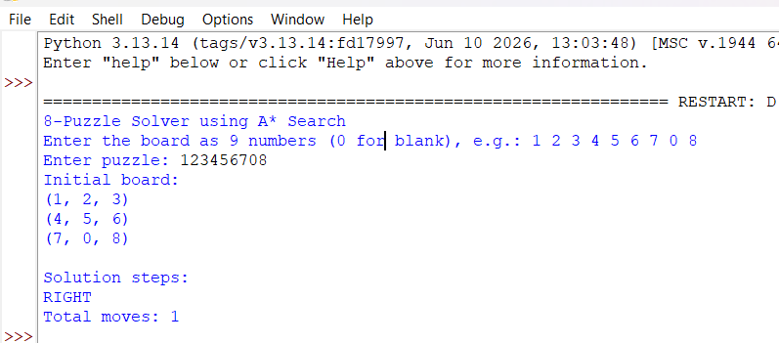

RESULT:
The puzzle is solved by finding a sequence of moves to reach the goal state.

